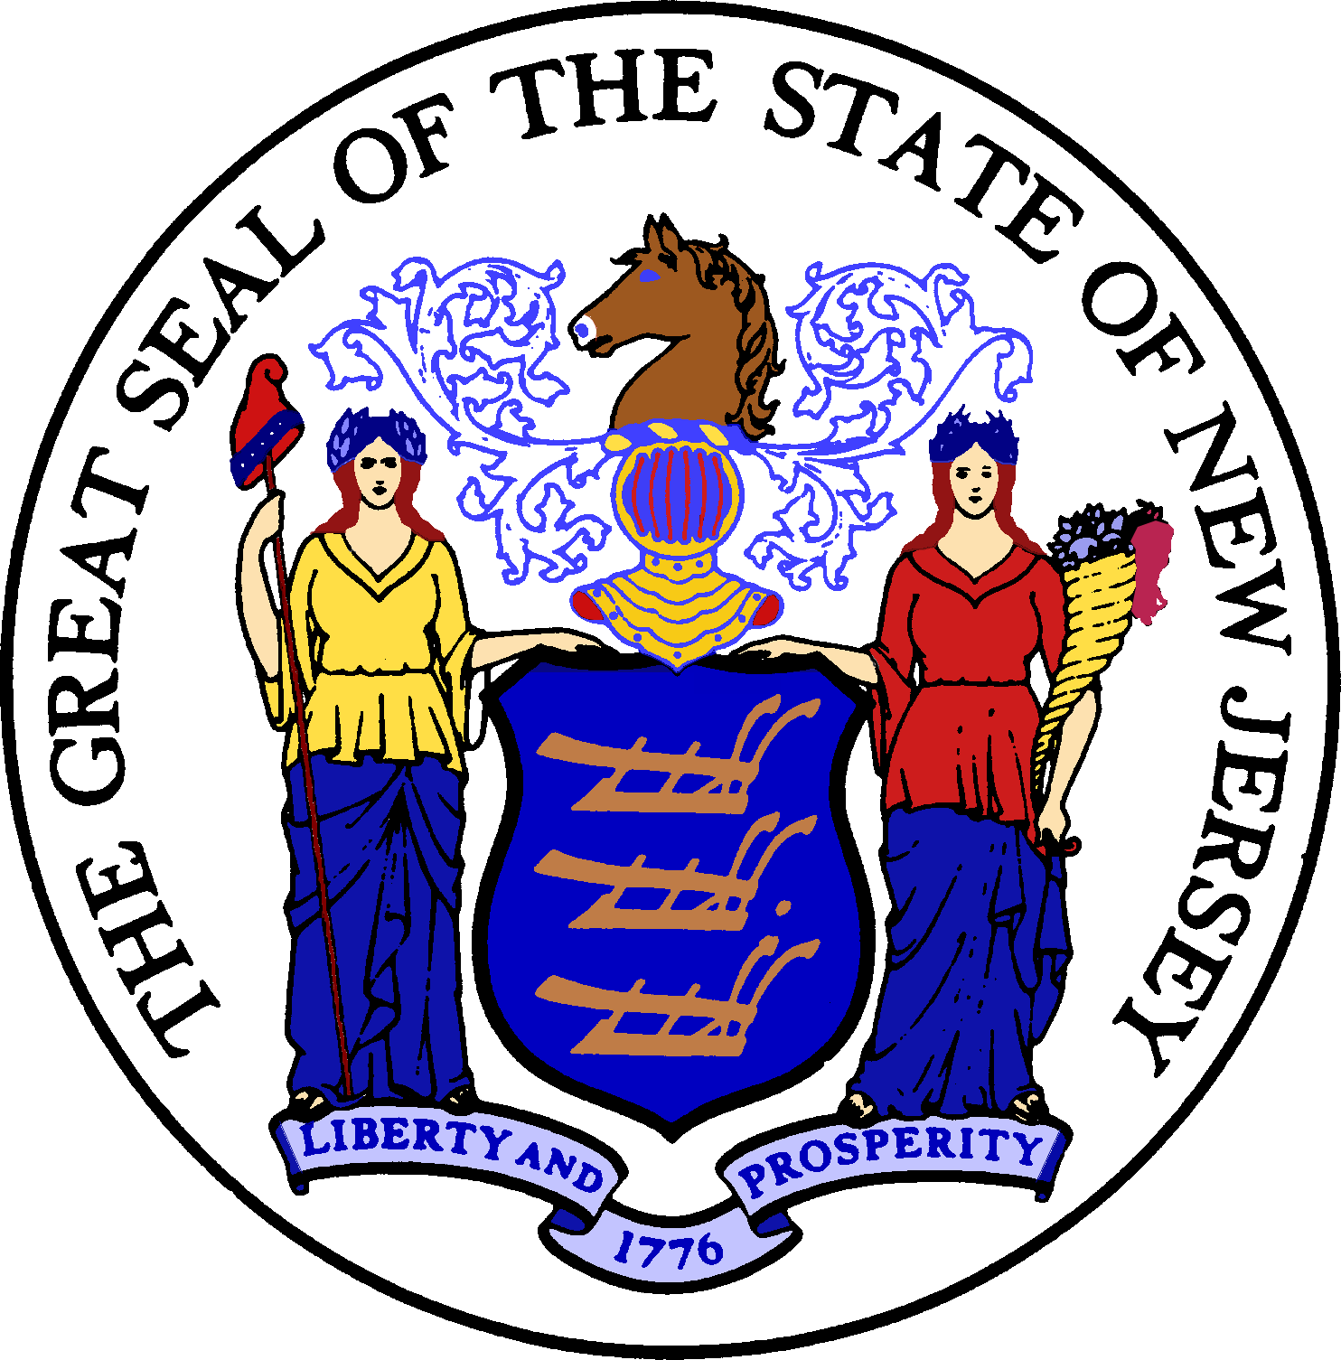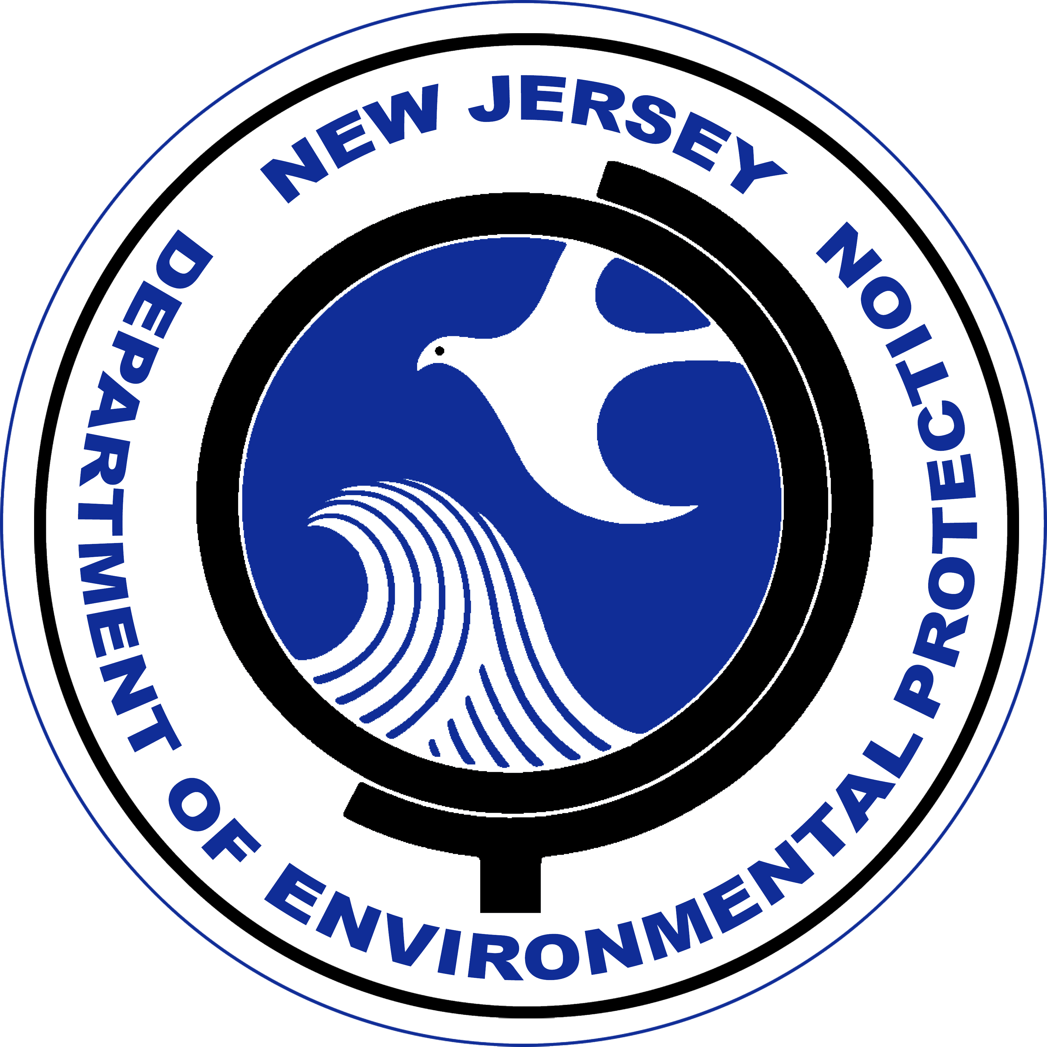

Construction of upgrades and improvements to the Sanitary Sewer System, located within Daddy Tucker Drive Right-of -Way, for a capital cost of $523,240.74, were financed by the New Jersey Water Bank (NJWB). The NJWB is a State Revolving Fund program jointly administered by the New Jersey Department of Environmental Protection (DEP) and the New Jersey Infrastructure Bank (Infrastructure Bank) and uses a combination of funds provided by the United States Environmental Protection Agency, the DEP, and the Infrastructure Bank to provide very low interest loans to borrowers for environmental infrastructure projects.

This project will provide water quality benefits by replacing deteriorated manholes, sewer laterals and sewer mains with a new watertight system, for residents and businesses in the Tuckerton Sewer Service Area, located in Little Egg Harbor Township, Ocean County, New Jersey.

State Revolving Fund programs around the nation provide states and communities the resources necessary to maintain and improve the infrastructure protecting our valuable water resources nationwide.